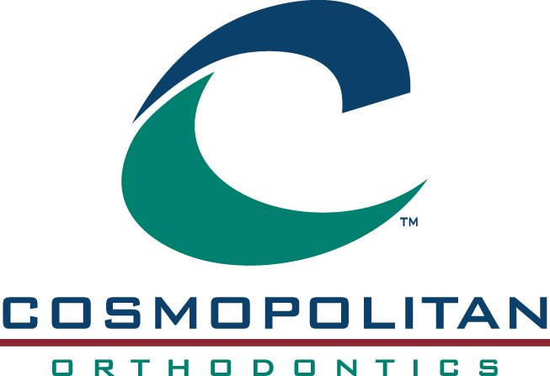

Sponsorship Requests

Cosmopolitan Orthodontics is committed to giving back to the communities that we serve. For your convenience, this form is provided to assist you in assembling the information needed in order for us to evaluate, consider and respond to your organization’s sponsorship request. Please complete your request and submit it at least 30 days prior to your due date to alex@CosmoOrtho.com. Please feel free to attach any additional supporting materials along with this request. Response time tends to be shortest for submissions made via our email.

Sponsorship Request Information:

Name of the organization that the donation is benefitting: ______________________________

Type of donation requested:

Sponsorship Advertising Silent Auction Item Other

Donation Level (Please attach description if multiple donation levels available)

Due Date for Response: ____________________________________________________

Contact information:

Name: ________________________________________________________________________

Email: ________________________________________________________________________

Phone number: _________________________________________________________________

Are you, or a family member a patient at Cosmopolitan Orthodontics? Yes No

Thank you for your request. Best efforts will be made to review your request and respond within a week. If you do not hear from our office within 10 business days, please feel free to contact our office at 952-469-3333 to confirm that your request was received.

